**4.4 Container Scaling Using Docker Swarm**

1. Initialize a docker swarm cluster using commands below:
   1. docker swarm init
   2. docker node

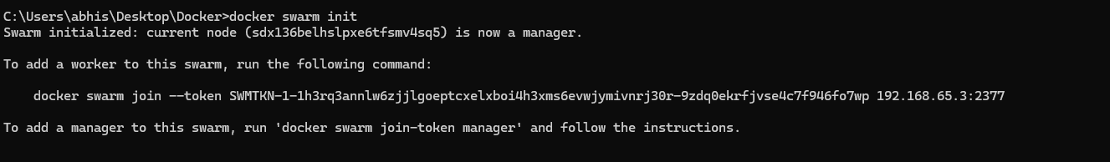

1. Deploy the custom image on the docker swarm cluster
   1. docker service create -p 80:80 –name webserver phpcode
   2. docker service ls
   3. curl localhost

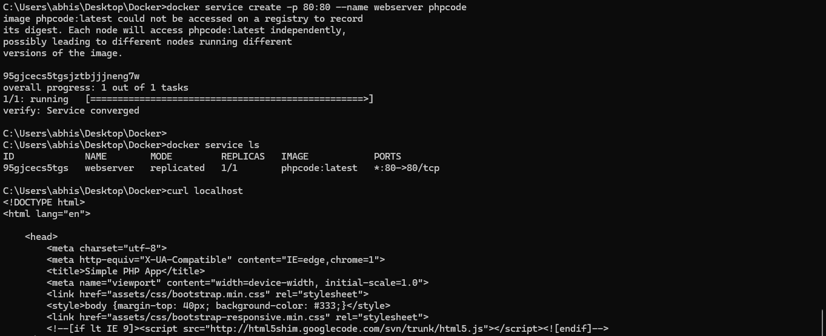

1. Create service for scaling

service create -p 8080:8080 --name myphpservice coutabhi/myphpcode:1.0

service ls

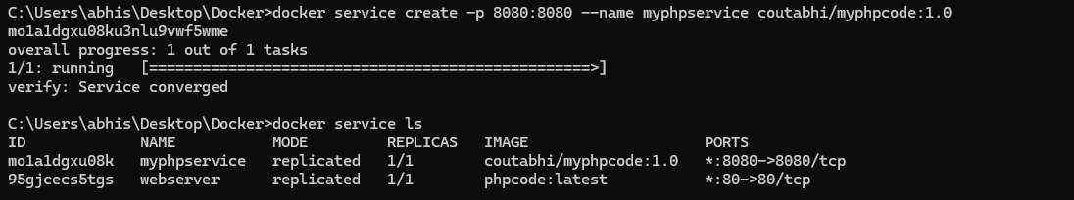

1. Use command to see the service
   1. docker service ps myphpservice



1. curl localhost:80

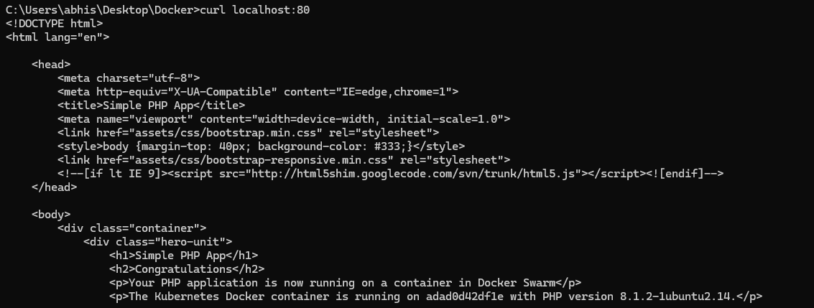

1. Scale up the docker swarm

docker service scale myphpservice=3

